**🔹 Phase 1: Problem Understanding & Scope**

**Introduction**

Accommodation management is a common challenge for multiple groups:

* **Tourists & Travellers** – need short-term stays for leisure, business trips, or events.
* **Students & Working Professionals** – require long-term affordable rentals such as PGs, hostels, or shared flats.

The **existing market** has several limitations:

* **Unverified Listings** – Many platforms allow fake or outdated property details.
* **Broker Dependence** – Manual, broker-driven processes inflate costs.
* **Communication Gaps** – Hosts and guests lack structured communication channels.
* **Low Transparency** – Guests face uncertainty regarding booking status, payments, and reviews.

**Proposed Solution**

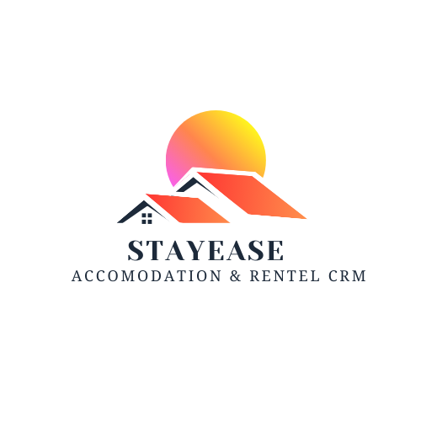**StayEase CRM** is a Salesforce-based CRM project designed to create a structured and trustworthy **accommodation and rental platform**. It takes inspiration from Airbnb’s short-term rental model while extending to long-term housing for students and professionals.

**Key Features of the Solution:**

* Centralized database of verified properties.
* Seamless booking flow for **short-term** and **long-term** stays.
* Role-based data access for **Admin, Hosts, Guests, and Managers**.
* Automation for booking status, payments, and complaint resolution.
* Reports and dashboards to monitor occupancy, revenue, and service quality.

**Objectives**

1. Create a **unified accommodation platform** with transparent workflows.
2. Support **short-term bookings** for tourists and **long-term rentals** for students/professionals.
3. Provide **role-based security** for data integrity.
4. Use Salesforce automation (Flows, Validation Rules, Approvals) to improve efficiency.
5. Deliver **business insights** through dashboards and reports.

**🔹 Phase 2: Org Setup & Security**

To implement the foundation of StayEase CRM, **roles, profiles, org-wide defaults, and permissions** are configured.

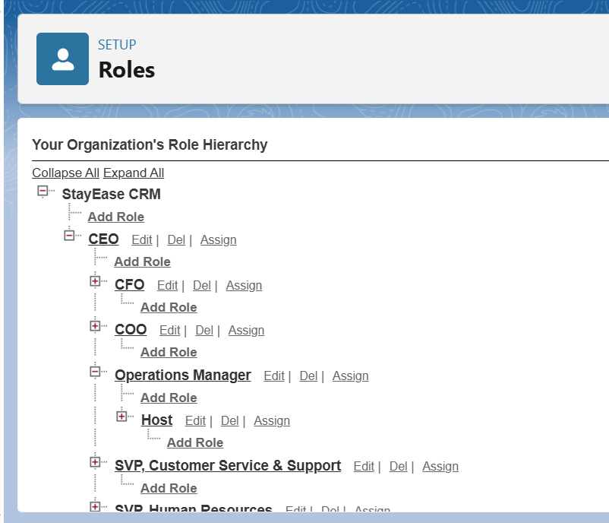**2.1 Roles (Role Hierarchy)**

* **CEO** → Top-level access; visibility into all records, reports, and dashboards.
* **Operations Manager** → Oversees all bookings, complaints, and escalations across the org.
* **Host** → Can only manage their own properties, bookings, and related complaints.
* **Guest (Traveller/Student/Professional)** → Can book properties and raise complaints related to their own bookings.
* **System Administrator** → Full access, controls setup and configurations (you).

**2.2 Profiles**

Profiles define **what a user can do** inside Salesforce.

* **Host Profile**
  + Can create, view, and edit only their properties.
  + Can view bookings related to their properties.
  + Limited access to complaints (only related ones)
* **Guest Profile**
  + Can create and manage only their own bookings.
  + Can raise complaints for their own bookings/properties.
  + Read-only access to property listings.
* **Operations Manager Profile**
  + Full access to all bookings and complaints.
  + Can intervene/escalate complaints.
  + Cannot perform system-level configurations.
* **CEO Profile**
  + Read-only access to all data.
  + Access to dashboards and reports for strategic decision-making.
* **System Admin Profile**
  + Full CRUD (Create, Read, Update, Delete) permissions on all objects.
  + Handles automation, security, and backend setup.

**2.3 Org-Wide Defaults (OWD)**

Default record-level security settings:

* **Property__c** → Private (Hosts can only see their properties).
* **Booking__c** → Private (Guests can see their own bookings, Hosts can see bookings related to their properties).
* **Complaint__c** → Private (Guests see their complaints; Ops Manager sees all).
* **Payment__c** → Private (Linked to bookings; visible only to Guest, Host, and Ops Manager).

**2.4 Sharing Rules**

* **Hosts** get automatic access to bookings made on their properties.
* **Ops Managers** get access to all complaints and escalated bookings.
* **CEO** gets read-only access to all objects for reporting.

**2.5 Permission Sets**

Additional flexibility beyond profiles:

* **Host_Extra_Access** → If needed, allow hosts to see limited guest details (like name & contact for bookings).
* **Ops_Manager_Analytics** → Access to advanced dashboards and reports.
* **Outcome of Phase 2:**  
  At this stage, the org is structured with a secure role hierarchy, profiles, permissions, and OWD rules. Each actor (Admin, CEO, Operations Manager, Host, Guest) has **only the data visibility and access they need**, ensuring data privacy, integrity, and smooth system operation.

## Phase 3 Documentation – StayEase CRM

## 1. Host Object

**Purpose:** Represents the property owner.

### Fields:

1. **Total Properties**
   * Data Type: Roll-Up Summary
   * Relationship: Master–Detail with Property
   * Summary Type: COUNT
   * Description: Counts how many properties the host has listed.
2. **Overall Host Rating**
   * Data Type: Roll-Up Summary
   * Relationship: Master–Detail with Property
   * Summary Type: AVERAGE
   * Field to Aggregate: Property Rating (on Property object)
   * Description: Shows the average rating across all properties owned by the host.

## 2. Property Object

**Purpose:** Represents an accommodation unit listed on the platform.

### Relationships:

* Master–Detail: Property → Host
* Master–Detail: Booking → Property

### Fields:

1. **Property Rating (Average)**
   * Data Type: Roll-Up Summary
   * Summarized Object: Booking
   * Summary Type: AVERAGE
   * Field to Aggregate: Guest Rating
   * Description: Average rating based on all guest reviews for this property.
2. **Total Bookings**
   * Data Type: Roll-Up Summary
   * Summarized Object: Booking
   * Summary Type: COUNT
   * Description: Number of times this property has been booked.

## 3. Booking Object

**Purpose:** Represents the reservation details when a Guest books a Property.

### Relationship:

* Master–Detail: Booking → Property

### Fields:

1. **Check-In Date**
   * Data Type: Date
   * Description: Start date of booking.
2. **Check-Out Date**
   * Data Type: Date
   * Description: End date of booking.
3. **Number of Guests**
   * Data Type: Number (2,0)
   * Description: Total number of people staying in this booking.
4. **Booking Status**
   * Data Type: Picklist
   * Values: Requested, Confirmed, Cancelled, Completed
   * Description: Tracks the current status of the booking.
5. **Guest Rating**
   * Data Type: Number (2,1), Range: 1–5
   * Description: Rating provided by the Guest for this booking/property.

## 4. Guest Object

### Fields:

* **Name** (Text)
* **Email** (Email)
* **Phone** (Phone)
* **Guest Type** (Picklist → Tourist, Student, Working Professional)
* **Total Bookings** (Roll-Up Summary → COUNT of related Bookings)
* **Average Rating Given** (Roll-Up Summary → AVERAGE of Guest Rating from Bookings)
* **Loyalty Points** (Number → optional/future use)

### Relationships:

* **Master–Detail**: Booking → Guest (One Guest can have many Bookings)

